# Disaster Recovery (DR) scenario

In the implemented system, we decided on the most budget disaster recovery option – Backup& Restore. In comparison to Pilot Light, Warm Standby and Active-Active it provides the simplest and cheapest way of recovering the system. This strategy is based on regular backups. In our case backups are made on multi-AZ databases deriving from one Region.

The difference in data between the time, when failure occurs and the latest backup refers to the data that will be lost. The maximal amount of them is defined by Recovery Point Objective (RPO). We assumed that business area in which Example Social Research Organization works allows us to use the simplest DR option.

## Backup configuration

During the creation of database we configured its type as a Multi-Availability Zones DB instance. This step results in the protection of our system against failures that may occur within a given Availability Zone.

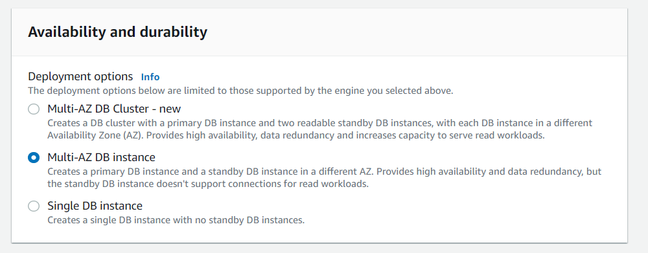

At the stage of backup configuration we decided to choose the shortest possible backup window – 30 minutes. Such a solution minimizes the data loss that can occur together with a potential system failure. The longest possible backup window is 23,5 hours.

In order to eliminate accidental deletion of database, we decided to enable the deletion protection mechanism.

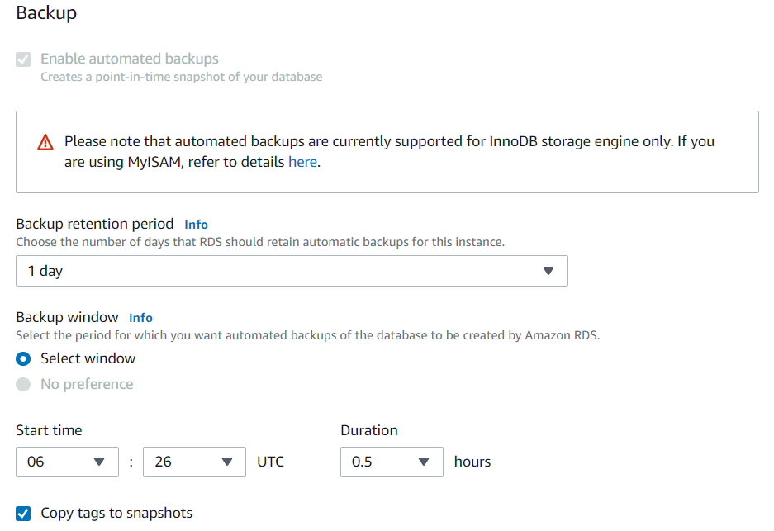

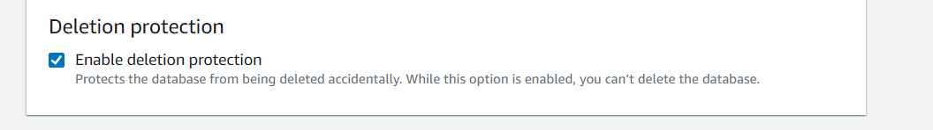

## **Restoration**

The process of restoration of an old RDS database state from backup takes place in the RDS -> *selected database instance* -> Maintenance & backups -> Snapshots. There are seen all available backups recently made. After the selection of a snapshot to restoration user is redirected to a helper questionnaire that enables to configure specification of a restored database once more.

